PC^2 Web Team

Team Meeting 01/24

horizontal line

24JANUARY **20**19 / 11:30 AM / Upper Division Lab

# ATTENDEES

Josie Isaacson, Andrew Combs, Dani Frodge, Ethan Holman

# PRIOR ACTION ITEMS

1. Ethan: Set up VM for testing
2. Everyone: Read over all specs for assignment
3. Everyone: run the software and get familiar with it

# NOTES

Controllers for folder structure on backend

ex) index.html/post/fileupload

State Pattern >> RXJS - gatekeeper to server

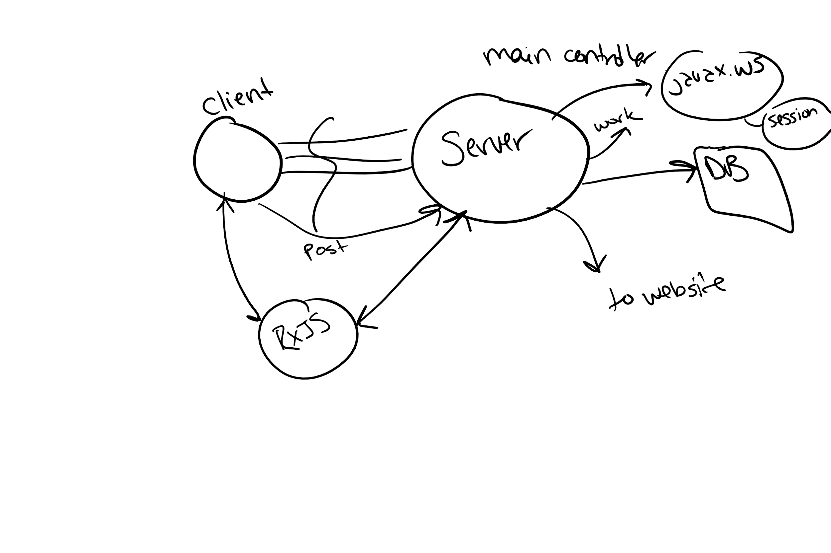

Code reviews:  
 Everyone looks at everything

Ethan created features and epics in DevOps to help with organization

Mockups:   
 Invision and Figma

*See workflow/team guidelines doc

-Possibly end sprints on Wednesday with sprint planning on Thursdays at 1130

-Daily meetings > post to discord by 2pm

-What are you working on?

-What are you planning on?

-Are you having any problems?

-Backlog planning > after class Monday

-Retrospectives > Wednesday after class or at least before we do our planning

# ACTION ITEMS

1. Ethan & Dani: Coding Standards
2. Andrew & Josie: start on SRS

# NEXT MEETING’S AGENDA

Next Meeting: